Design Review
Submission Detail | Student Entry
GROUP ID | CSC14
GITHUB REPO LINK | https://github.com/vanessayee/Embedded-System-Group-14-Project.git

Purpose
Document the system requirements, hardware connections, RTOS task structure, behavioural models, assumptions, and AI-supported design reasoning before major implementation. Treat this Week 6 submission as an architecture freeze before full integration and Tribunal 1. The design may change later, but major changes must be justified with engineering evidence.

How to use this template
- This is an architecture-freeze document. The team may improve the design later, but major changes must be justified during Tribunal 1.
- Use AI assistants for ideation, critique, and gap checking. Do not paste AI output directly as the final design.
- Summarise, challenge, correct, and justify AI suggestions using engineering reasoning.
- Keep all artefacts consistent: requirements, pin layout, RTOS task table, task interaction diagram, statecharts, assumptions, and AI evidence.

Team Role and Subsystem Ownership
Identify each buddy’s primary subsystem responsibility. The role does not need to match the examples exactly, but every major hardware and software responsibility should have a clear owner.
Buddy | Student ID | Primary subsystem / responsibility
Buddy 1 | 2501573 | WiFi/MQTT communication, command handling and telemetry
Buddy 2 | 2502591 | Motion control: motor drivers, wheel encoders, PID speed control, encoder-based turning
Buddy 3 | 2501720 | Line tracking, barcode, or perception inputs
Buddy 4 | 2500320 | IMU-based motion and terrain monitoring (hump, tilt, collision)
Buddy 5 | 2502075 | Ultrasonic scanning, obstacle profiling, avoidance and line recovery

Submission Instructions
- Complete every required section.
- Diagrams may be produced using any suitable tool, but labels must remain readable when inserted into this document.
- AI assistants may support drafting. The team remains responsible for technical correctness, consistency, and the ability to explain every decision.
- Use consistent names across the requirements, hardware sketch, task table, task interaction diagram, and statecharts.

1. Requirements
State what the system must do and the important quality or timing constraints. Requirements should be specific, testable, and traceable to the proposed design (you may add more FR and/or NFR as needed).

1.1 Functional Requirements
ID | Requirement
FR1 | The robotic car shall follow the black line track automatically using its IR sensors.
FR2 | The robotic car shall be able to scan and decode the barcodes placed along the track.
FR3 | The robotic car shall execute navigation commands encoded by the detected barcodes, including Turn Left, Turn Right, Go Straight, and U-Turn, using encoder-based motion control.
FR4 | The robotic car shall use encoder feedback to control and monitor its movement during straight-line motion and turning maneuvers.
FR5 | The car shall detect when it goes over speed humps and use the IMU to estimate their height.
FR6 | The system shall record the measured hump data and identify the highest hump peak detected during the complete run.
FR7 | The system shall transmit telemetry, including motor speed, sensor status, current system state, and relevant measurement data, over Wi-Fi using MQTT.
FR8 | When an obstacle is detected on the path, the system shall stop or reduce vehicle speed before initiating obstacle scanning and profiling.
FR9 | The system shall use the ultrasonic sensor mounted on the servo to scan a detected obstacle and estimate its position, width, and available clearance.
FR10 | Based on the generated obstacle profile, the system shall determine an appropriate avoidance action and send the required stop, turn, reverse, or movement command to the Motion Control subsystem.
FR11 | After completing an obstacle-avoidance maneuver, the robotic car shall search for and reacquire the original black line before resuming normal navigation.
FR12 | The robotic car shall enter a Safe Stop/Fault state if an obstacle cannot be safely avoided, obstacle profiling fails, or the original line cannot be reacquired within the configured recovery timeout.
FR13 | The communication subsystem shall publish periodic heartbeat messages and report whether the robot is online, disconnected or recovering its connection.
FR14 | The telemetry processing system shall validate received messages and store valid required measurements in a configured database, with PostgreSQL for telemetry statistic. The monitoring interface shall display current robot status and historical telemetry obtained from the configured database.
FR15 | The system shall detect invalid or unavailable sensor data and prevent that data from causing unsafe motor or navigation commands.
FR16 | The system shall calibrate the IMU before normal motion and terrain monitoring begins, and shall apply the calculated calibration offsets to subsequent IMU measurements.
FR17 | The system shall use IMU measurements to detect changes in vehicle tilt and orientation and report relevant tilt events.
FR18 | The system shall analyze IMU acceleration and motion data to classify relevant vehicle motion and detect sudden impacts or collisions.
FR19 | The system shall calculate the vehicle turn rate from IMU data and report turn rate and detected motion events.

1.2 Non-Functional Requirements
ID | Requirement
NFR1 | The software has to run on a Raspberry Pi Pico with the Robo Pico platform, using the micro T-Kernel RTOS and the Pico C SDK written in C.
NFR2 | All code must follow the Barr C Coding Standard.
NFR3 | Because hardware resources are limited, memory, processing power, and battery usage need to be managed efficiently
NFR4 | The line tracking should still work reliably even if the lighting changes a bit, the track has small imperfections, or the speed varies.
NFR5 | When avoiding obstacles, the car should try not to drift too far off its original route.
NFR6 | The stop() function shall halt motor output within 100ms of being called, to support obstacle avoidance and safety events.
NFR7 | Straight line motion shall not deviate more than 15 mm from the intended path per 1m travelled, under nominal track conditions.
NFR8 | A commanded turn shall achieve the target heading within ± 10 degrees.
NFR9 | Loss of WiFi, MQTT, the Raspberry Pi server or the database shall not prevent the robot from executing local motion-control and safety functions.
NFR10 | WiFi and MQTT reconnection shall use timed, non-blocking retries with a capped delay.
NFR11 | Invalid, incomplete or incorrectly formatted MQTT messages shall be rejected without crashing or blocking the communication task.
NFR12 | When transitioning directly from Moving Straight to Turning with a command already queued, the robot shall decelerate to a fixed creep speed (e.g. 10 - 15% of cruise speed) before beginning the turn, rather than turning at full speed or requiring a full stop.
NFR13 | The IMU monitoring task shall sample and process sensor data at a fixed periodic interval sufficient to reliably detect hump, tilt, turning and collision events without blocking other RTOS tasks.
NFR14 | IMU measurements shall be filtered or validated to reduce false hump, collision and tilt detections caused by normal sensor noise and vehicle vibration.

2. Hardware Integration Pin Layout
Sketch how sensors, actuators, displays, communication modules, and power connections interface with the Robo Pico. Label pins and interfaces such as GPIO, ADC, PWM, I2C, SPI, and UART.
Device / Module | Type | Signal Name | Sensor label | Pico GPIO Pin | Interface | Notes / RTOS Task Owner
Left IR Sensor | Sensor | IR_LEFT | Grove 2: D0 / A0 / VCC / GND | GP2 / GP3 / 3.3V / GND | GPIO Input | Line Following Task — Buddy 3. D0 used for line following; A0 connected through Grove but remain unused in software.
Centre IR Sensor | Sensor | IR_CENTER | Grove 5: D0 / A0 / VCC / GND | GP6 / 3.3V / GND | GPIO Input | Line Following Task — Buddy 3. D0 → GP6; A0 not connected.
Right IR Sensor | Sensor | IR_RIGHT | Grove 6: D0 / A0 / VCC / GND | GP27 / NC 3.3V / GND | GPIO Input | Line Following / Barcode Task — Buddy 3. D0 used; A0 connected through Grove but remain unused in software.
IMU Sensor | Sensor | IMU_SDA / IMU_SCL | Grove 4: SDA / SCL / VCC / GND | GP16 / GP17 / 3.3V / GND | I2C0 SDA / I2C0 SCL | IMU / Terrain Task — Buddy 4
HC-SR04 Ultrasonic Sensor | Sensor | US_TRIG / US_ECHO | Grove 3: TRIG / ECHO / VCC / GND | GP4 / GP5 / 3.3V / GND | GPIO Output / GPIO Input pulse timing | Obstacle Scan Task — Buddy 5.
Scanning Servo SG90 | Actuator | SERVO_PWM | Servo Port 4: Signal / V+ / GND | GP15 / Servo Power / GND | PWM | Obstacle Scan Task — Buddy 5. Uses dedicated Robo Pico servo header.
Left Encoder | Sensor | ENC_L_A / ENC_L_B | Grove 1: Encoder A / Encoder B / VCC / GND | GP0 / GP1 / 3.3V / GND | GPIO Input / IRQ | Motion Control Task — Buddy 2
Right Encoder | Sensor | ENC_R_A / ENC_R_B | Grove 7: Encoder A / Encoder B / VCC / GND | GP7 / GP28 / 3.3V / GND | GPIO Input / IRQ | Motion Control Task — Buddy 2
Left DC Motor | Actuator | MOTOR_LEFT_A / MOTOR_LEFT_B | M1A / M1B → MOTOR 1 | GP8 / GP9 | On-board motor driver | Motion Control Task — Buddy 2. Physical motor +/− wires connect to MOTOR 1.
Right DC Motor | Actuator | MOTOR_RIGHT_A / MOTOR_RIGHT_B | M2A / M2B → MOTOR 2 | GP10 / GP11 | On-board motor driver | Motion Control Task — Buddy 2. Physical motor +/− wires connect to MOTOR 2.
Pico W WiFi | Communication | WIFI_MQTT | Internal WiFi | Internal | WiFi | Telemetry & Communication Task — Buddy 1
Power Supply | Power | SYSTEM_POWER | 5V USB Power Bank → VIN/GRD Terminal Block | N/A | Power | Main power supply for Pico / Robo Pico system.
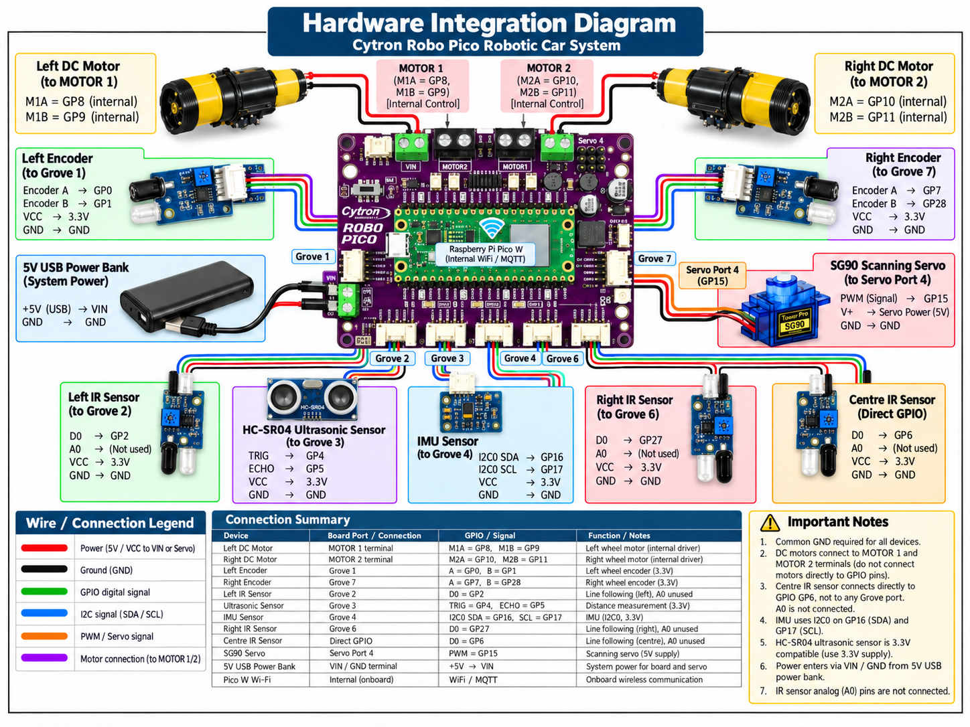

3. RTOS Task Table
List the proposed RTOS tasks. Priorities are preliminary at Week 6 and must be justified.
Task |  | Purpose | Inputs | Outputs | Trigger | Priority
WiFi and MQTT Communication Task | Maintain WiFi and MQTT connections, publish telemetry and heartbeat messages, subscribe to command topics, validate received commands, and recover from connection failures |  | Telemetry queue, network configuration, MQTT command messages | Published MQTT messages, communication status, acknowledgements and validated command queue | Event-driven with periodic heartbeat and reconnection checks | Medium
Telemetry Collection Task | Collect the latest robot status and sensor measurements, add timestamps, and format the data into a telemetry message |  | Sensor readings, motion status, obstacle status, battery/system status | Formatted telemetry message placed in telemetry queue | Periodic, approximately 500–1000 ms | Low
Motion Control | Run PID speed control; translate move/turn commands into motor output; decelerate to a fixed creep speed before executing a queued turn instead of a full stop |  | Motion command sources (line/steering, barcode navigation, obstacle avoidance, supervisory stop/mode requests), encoder ticks (via Encoder ISR) | Motor PWM and direction signals, telemetry queue, motion complete notification | Periodic, 20- 50 ms | High
Line Following Task | Process the 3 IR sensors and keep the car aligned with the black line |  | Left, center and right IR sensors | Line / steering commands to Motion Control (Line / Steering Command Path); line lost / line reacquired status | Periodic, 20-50ms | High
Barcode Decoding Task | Detect and decode barcode patterns into navigation commands |  | Bar code pattern | Navigation commands | Event-driven | Medium
IMU Monitoring System | Read and process the IMU data to detect the tilt, turning, motion and collision of the vehicle. |  | Accelerator & Gyroscope reading, Calibration offsets. | Cleaned IMU Data, tilt/orientation, turn rate, motion state, collision events. | Periodic, 10ms | High
Hump & Terrain Analysis | Detect humps, estimate height and track highest hump |  | IMU Data | Hump detected, hump height, highest hump | Event-driven | Medium
Obstacle Scan | Control servo and collect ultrasonic distance measurements |  | Ultrasonic, servo | Scan samples, obstacle detected | Periodic/event-driven | High
Obstacle Profile | Convert scan data into obstacle geometry |  | Scan sample queue | Location, width, clearance | Queue/event | Medium
Avoidance & Recovery Task | Decide and execute stop/turn/reverse/recovery sequence |  | Obstacle profile, line reacquisition status | Motion commands, recovery events | Event-driven | High

Priority and ownership justification:
The task priorities are based on how quickly each task needs to respond and how directly it affects the robot's movement and safety.
High-priority tasks require fast or frequent responses, especially where they directly control movement, detect obstacles, or monitor the robot's condition. These include Motion Control, Line Following, IMU Monitoring, Obstacle Scan, and Avoidance & Recovery. IMU Monitoring runs at a tighter 10ms period than the other High-priority tasks, since tilt and collision detection depend on catching rapid changes in acceleration and orientation that a slower sampling rate could miss. Where multiple High-priority tasks are ready to run at the same time, the RTOS resolves contention via round-robin scheduling at equal priority, and periods are staggered in implementation (for example, Motion Control and Line Following both run every 20–50ms but are offset from each other) to avoid simultaneous triggering wherever possible. None of these tasks are ranked above one another, since each hands off data or commands via a queue and continues, rather than blocking on another High-priority task's full completion within a cycle.
Medium-priority tasks are important for navigation and processing but can tolerate some delay without risking safety or immediate loss of control. These include WiFi and MQTT Communication, Barcode Decoding, Hump & Terrain Analysis, and Obstacle Profile.
Low-priority tasks are the least time-critical and do not directly control the robot. Telemetry Collection is given lower priority on this basis, since a short delay in reporting status has no effect on the robot's physical behaviour.
Task ownership is divided according to each task's main responsibility: each task is owned by the subsystem responsible for its inputs and outputs, which avoids overlapping responsibility and makes it clear which subsystem is accountable for each function. Tasks communicate with each other through sensor data, queues, commands, and notifications where required.

4. Task Interaction Diagram
Show RTOS tasks, queues, semaphores, mutexes, event groups, notifications, and data flow. Clearly distinguish software tasks from hardware devices and interrupt service routines.
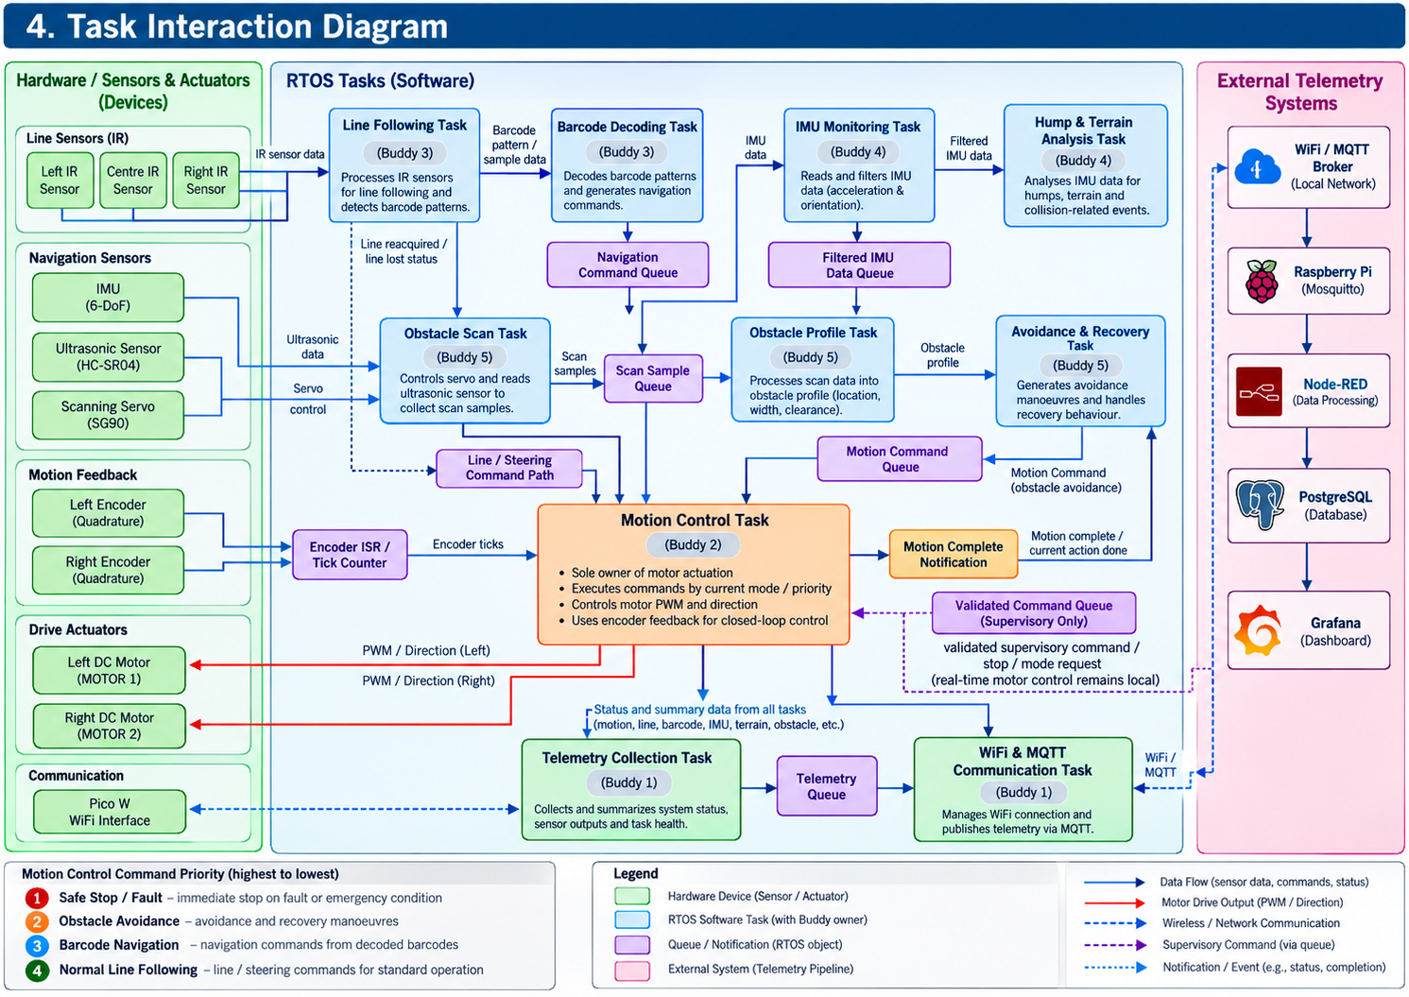

Brief explanation of the main communication paths:
Buddy 3 processes IR sensor data for line following and barcode decoding, generating navigation commands for Motion Control. Buddy 4 processes IMU measurements for hump detection, vehicle orientation, turn rate and collision-related events. Buddy 5 controls ultrasonic scanning and obstacle profiling, then generates high-level avoidance and recovery commands for the Motion Control Task.
All movement requests are passed through the defined command-handling mechanism, with safety and obstacle-avoidance commands taking precedence over normal navigation. Buddy 2 retains exclusive ownership of motor PWM and direction outputs. Buddy 1 collects telemetry and handles Wi-Fi/MQTT communication, including validated supervisory commands where enabled.
Mission-level coordination is implemented through task events, state information and prioritized commands rather than a separate Vehicle Controller RTOS task. During obstacle handling, normal line-following commands are suspended to prevent conflicting movement requests. After avoidance, Buddy 5 uses line-reacquisition information from Buddy 3 to determine whether normal navigation may resume or whether a Safe Stop/Fault condition must be reported.

5. System-Level Statechart
Model the operating states of the entire system. Label transition events or conditions. Include relevant fault, stop, or recovery behaviour.
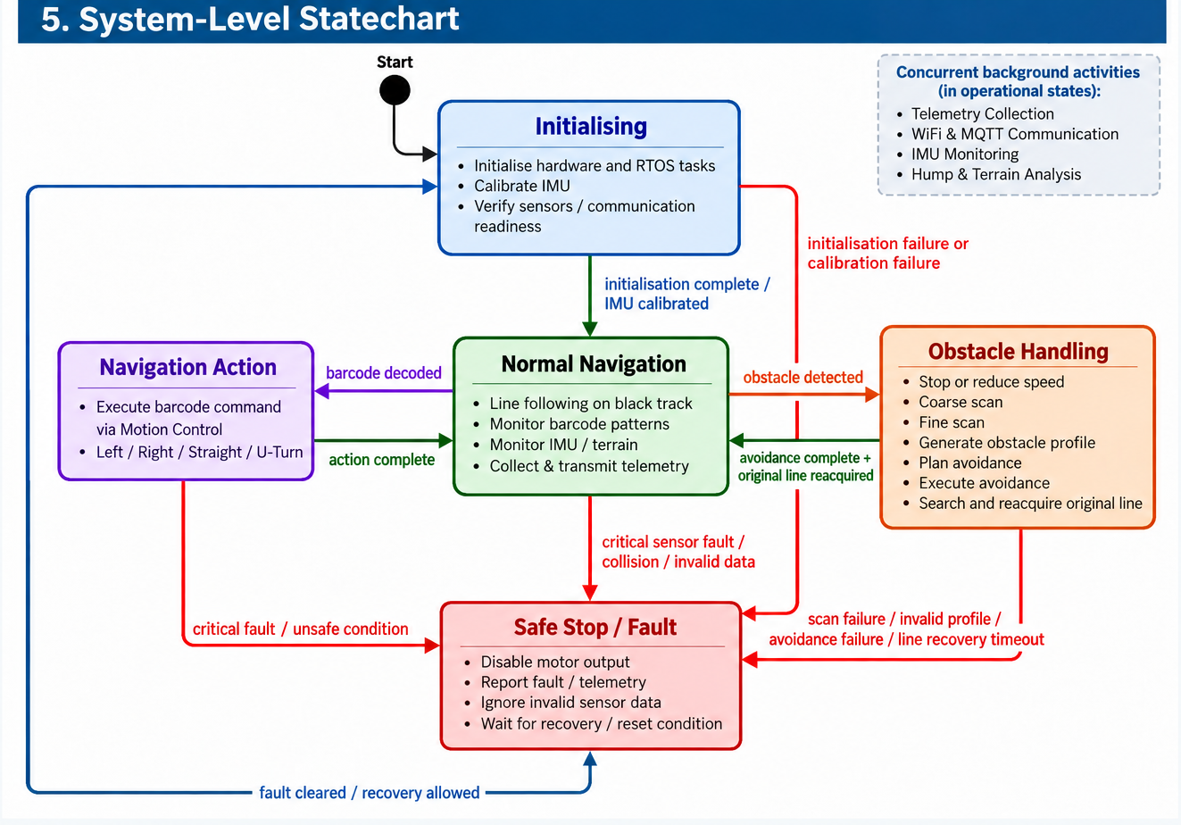

Explain the main states and any important assumptions:
The system begins by initialising the robot hardware and subsystems before entering normal line-following operation. During normal operation, Buddy 3 maintains line tracking and detects barcodes that may trigger navigation actions. Buddy 4 independently monitors IMU data for humps and terrain-related events, while Buddy 1 reports system telemetry. If an obstacle is detected, normal navigation is interrupted and the system enters Obstacle Handling. Buddy 5 stops or reduces vehicle motion, scans and profiles the obstacle, plans an avoidance manoeuvre and requests the required motion through Buddy 2. After avoidance, the system attempts to reacquire the original line before returning to normal line following. If scanning, avoidance or line recovery fails, the system enters Safe Stop/Fault and motor output is stopped. The system assumes that subsystem events are communicated reliably and that Motion Control remains the sole owner of motor actuation.

6. Subsystem Statecharts

6.1 Subsystem Statechart 1
Field | Student Entry
Subsystem name | WiFi Communication, Command and Telemetry
Related RTOS task(s) | WiFi and MQTT Communication Task
Purpose | Establish WiFi and MQTT communication, publish robot telemetry and heartbeat messages, receive and validate remote commands, and pass accepted commands to the appropriate robot task.
Reason a statechart is needed | Communication depends on a sequence of connection steps and can fail during operation. Explicit states define when messages may be exchanged, how failures are detected, and how the subsystem reconnects without blocking robot control.

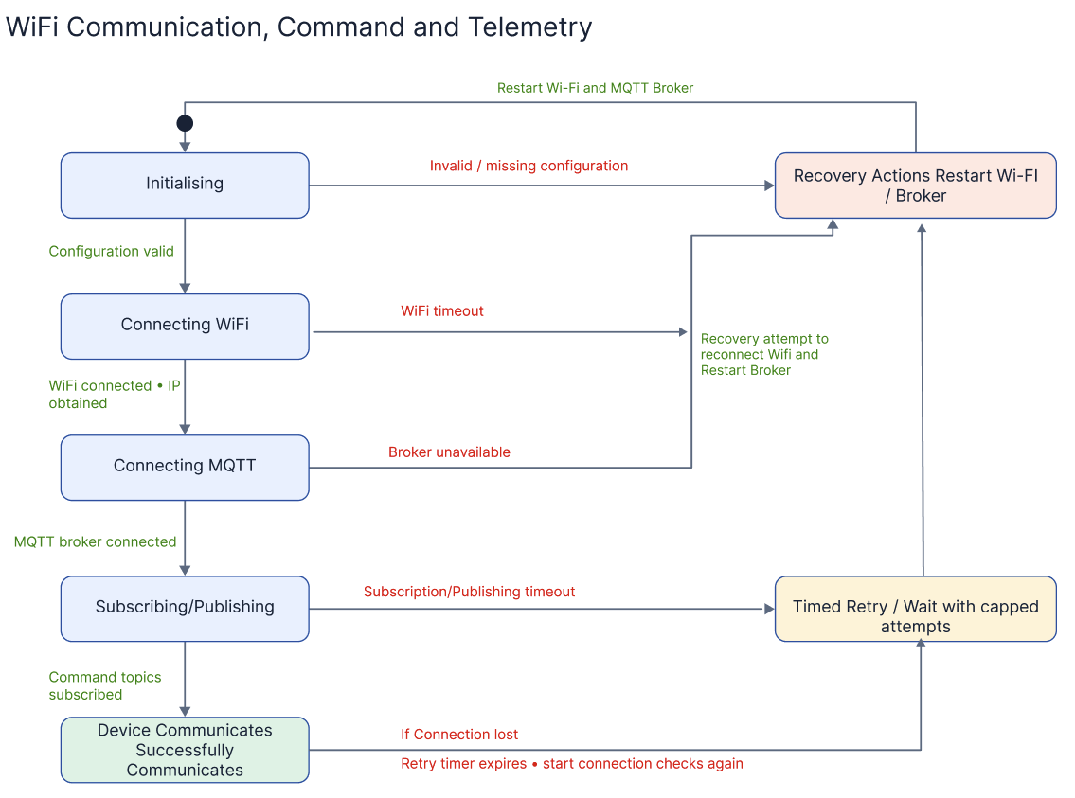
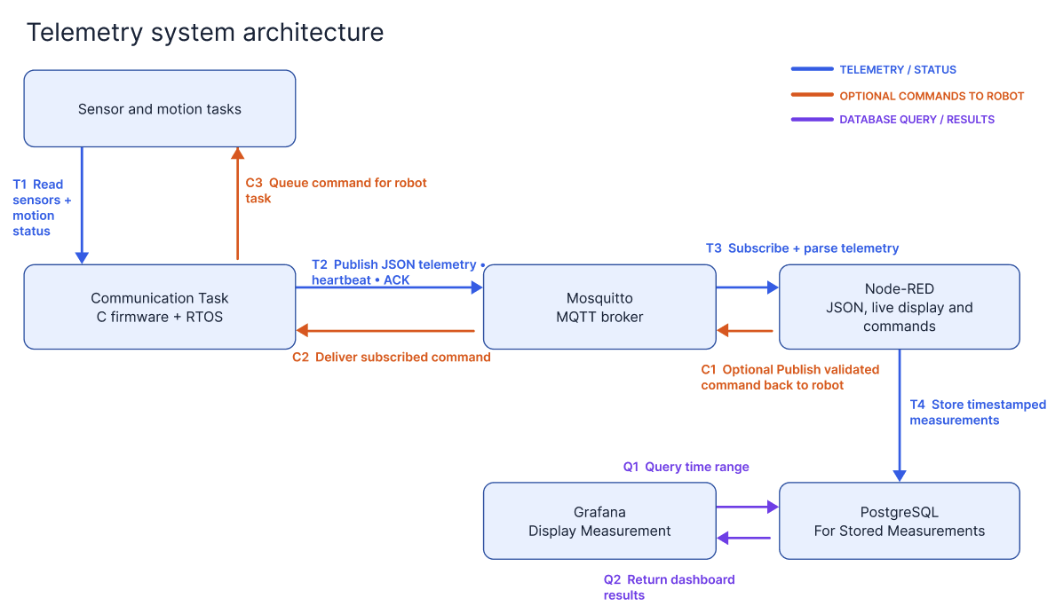
Brief explanation of states, events, and fault handling:
The WiFi communication statechart describes how the subsystem progresses from initialisation to WiFi connection, MQTT broker connection, topic subscription and normal communication, where telemetry, heartbeat messages and acknowledgements are published. Events such as valid configuration, successful connection, subscription confirmation, timeouts and connection loss trigger transitions between these states. Invalid configuration activates recovery, while temporary WiFi, MQTT or subscription failures activate timed retries before the connection process begins again.
The telemetry system architecture then describes how sensor and motion data is passed to the robot’s communication task, formatted as JSON and published through Mosquitto to Node-RED. Node-RED validates and processes the messages before writing timestamped measurements to PostgreSQL, while Grafana queries PostgreSQL to display dashboards and historical graphs. Node-RED may also send optional high-level supervisory commands through Mosquitto to the robot’s communication task, but real-time motor control and safety behavior remain within the robot firmware.

6.2 Subsystem Statechart 2
Field | Student Entry
Subsystem name | Motion Control
Related RTOS task(s) | Motion Control Task
Purpose | Converts high-level move/turn commands into closed-loop motor output using PID control and encoder feedback, and reports when a move completes or a fault occurs.
Reason a statechart is needed | Motion Control behaves very differently depending on what it's currently doing. For example, an incoming stop() call must interrupt a turn differently than it interrupts a straight move, and a fault (like an encoder failure) needs to override normal operation. A statechart makes these mode-dependent behaviors and transitions explicit and testable, rather than leaving them implicit in code.

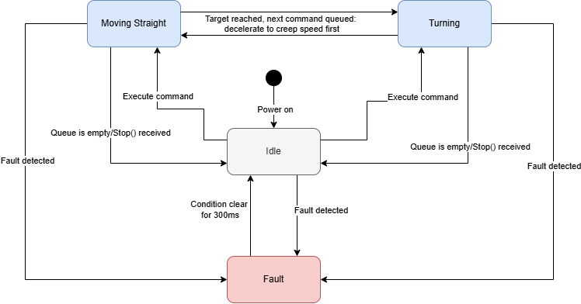
Brief explanation of states, events, and fault handling:
The Motion Control subsystem operates in one of four states. It starts in Idle, with motors stopped, and enters Moving Straight or Turning when it receives a move or turn command from the navigation-owning task. When the encoder-measured distance or angle target is reached, the task checks its command queue: if empty, it returns to Idle; if a turn is already queued while completing a straight segment (or vice versa), it decelerates to a fixed creep speed rather than stopping fully, then transitions directly into the next active state, reducing dead time between manoeuvres while keeping turning accuracy predictable. A stop() request from the Safe Stop/Obstacle Avoidance path halts motor output within 100 ms and returns the task to Idle, discarding any queued commands. From any state, a fault condition forces an immediate transition to Fault, where motor output is disabled regardless of any queued command. Since real-time motion and safety control is local to the robot and does not depend on remote commands, recovery from Fault is automatic: the task returns to Idle only once the fault flag (e.g. stall, invalid encoder reading) has cleared and stayed clear continuously for a debounce window (e.g. 300 ms), preventing the robot from resuming motion on a momentary or flickering fault.Motion Control's Fault state is a local, low-level protection. Returning to Idle leaves the motors stopped and does not resume motion: Motion Control only moves again when it receives a new command, and no navigation or avoidance commands are issued while the system is in Safe Stop/Fault.

6.3 Subsystem Statechart 3
Field | Student Entry
Subsystem name | Barcode Decoding and IR Line Following
Related RTOS task(s) | Line Following Task – runs periodically to process 3 IR sensor inputs and control line following  Barcode Decoding Task – detects and decodes barcode patterns into navigation commands
Purpose | To continuously follow the black line using the 3 IR sensors, detect barcode patterns along the track, decode them into navigation commands, and send the commands to the motion control system.
Reason a statechart is needed | A statechart is necessary because the subsystem needs to switch between distinct operational modes, such as normal line following, detecting a barcode pattern, decoding the barcode, and executing the navigation command (Turn Left, Turn Right, Go Straight, or U-Turn) before safely resuming normal line following. Without clear states, the robot may confuse normal line variations with barcode patterns and perform the wrong action.

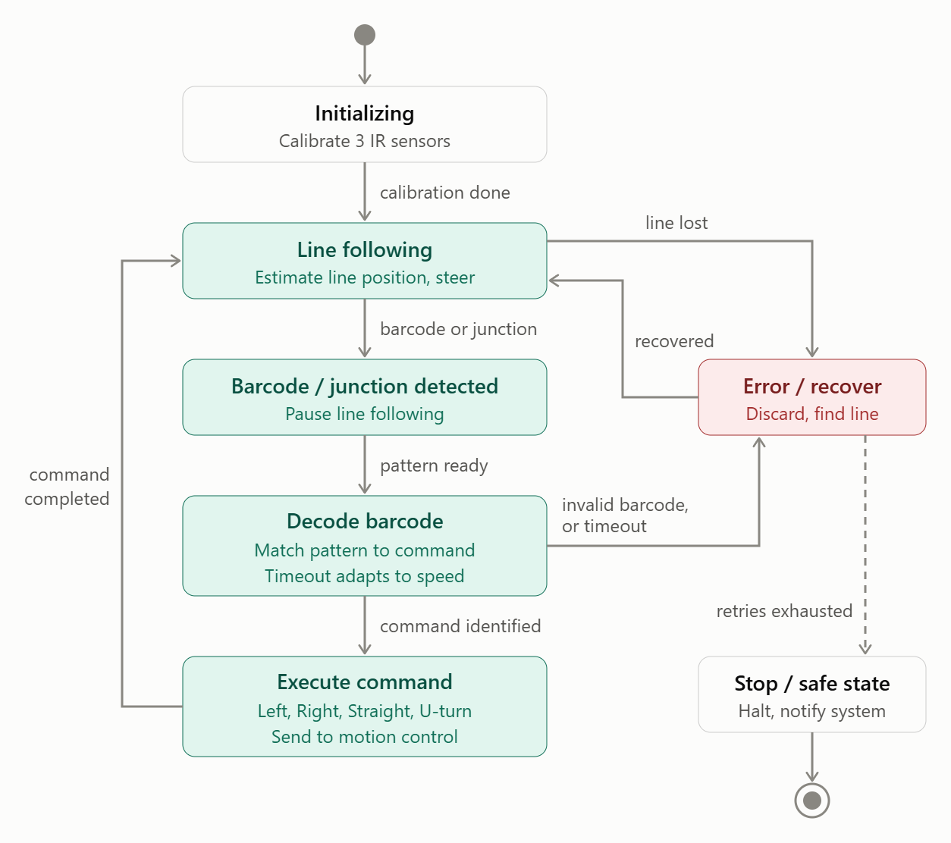

Brief explanation of states, events, and fault handling:
States: The subsystem starts in the Initializing state, where the 3 IR sensors are calibrated. Once calibration is done, it enters the Line following state, where the IR sensor readings are used to estimate the line position and steer the car along the track. When a barcode or junction is detected, it changes to the Barcode / junction detected state and temporarily pauses normal line following. It then moves to the Decode barcode state, where the barcode pattern is matched to the correct navigation command. After that, it enters the Execute command state, where the command (Turn Left, Turn Right, Go Straight, or U-turn) is sent to the motion control system and carried out. Once the command is completed, the subsystem returns to Line following.
Events: The main events are calibration done, a barcode or junction being detected, the barcode pattern being ready for decoding, the command being successfully identified, and command execution being completed.
Fault handling: If the line is lost, the barcode is invalid, or the barcode cannot be decoded within the time limit, the subsystem enters the Error / recover state. The time limit adapts to the robot’s speed. In this state, it discards the faulty input and searches for the line so the robot can resume Line following. If recovery fails after repeated retries, the subsystem enters the Stop / safe state, where the motors are halted and the system is notified, and the statechart ends.

6.4 Subsystem Statechart 4
Field | Student Entry
Subsystem name | IMU-Based Motion and Terrain Monitoring
Related RTOS task(s) | IMU Monitoring System  Hump & Terrain Analysis Task
Purpose | To monitor and receive IMU data to detect tilt, humps, get peak height, motion state, collision events and turn rate which all the relevant information will be reported to the Vehicle Communication and Telemetry system for logging and use by other subsystems as needed.
Reason a statechart is needed | A state chart is required to show the different states of the IMU subsystem and how it moves from one state to another when events such as hump detection, collision detection or sensor faults occur.

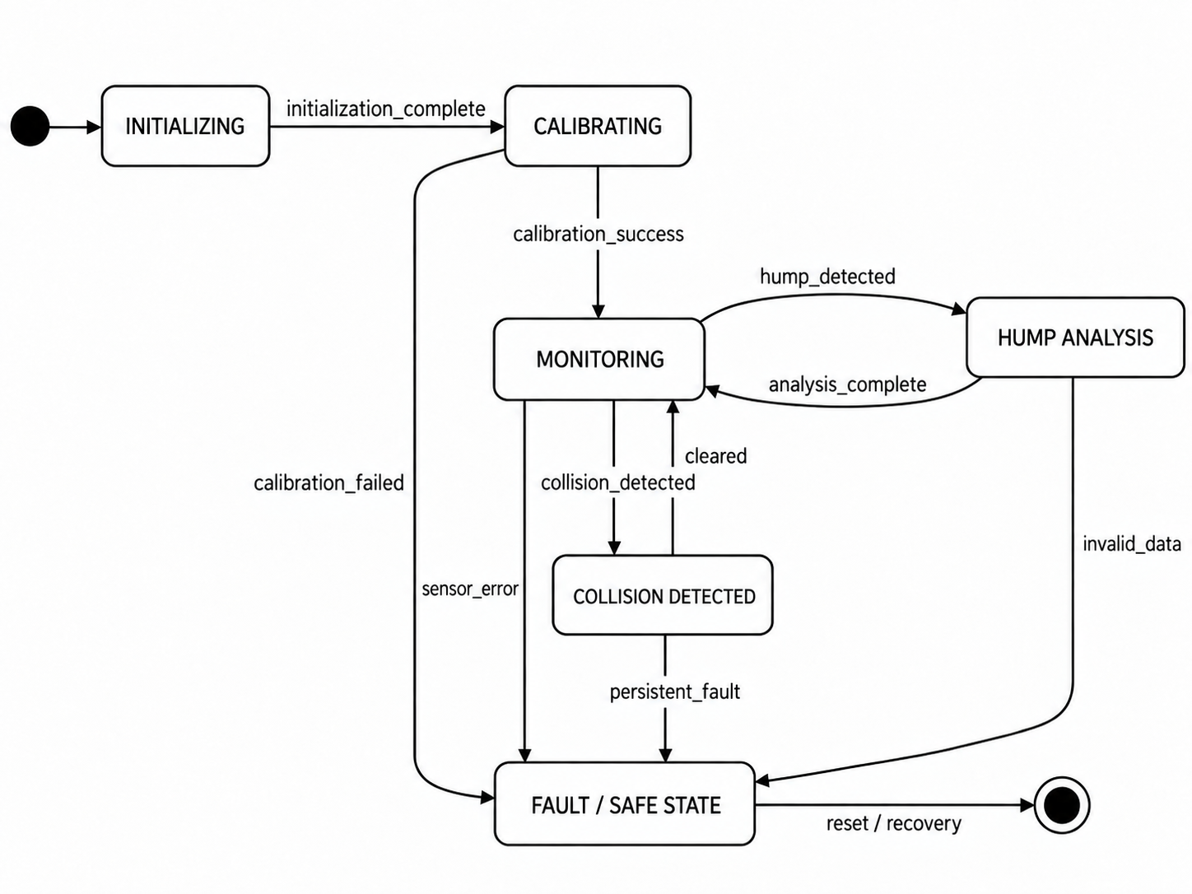
Brief explanation of states, events, and fault handling:
States: The subsystem starts in the Initializing state, where the IMU is set up, before moving to Calibrating to establish the sensor baseline. After calibration is successful, it enters the Monitoring state, where IMU data is checked continuously. If a hump is detected, it moves to Hump Analysis. If a collision is detected, it moves to Collision Detected.
Events: The main events that cause state changes include initialization_complete, calibration_success, hump_detected, analysis_complete, collision_detected, and cleared. These events determine when the subsystem moves from one operating state to another.
Fault handling: If calibration fails or invalid IMU data is detected, the subsystem enters the fault state and stops using the unreliable sensor data until the system is reset or recovered.

6.5 Subsystem Statechart 5
Field | Student Entry
Subsystem name | Adaptive Ultrasonic Scanning and Obstacle Profiling
Related RTOS task(s) | Obstacle Scan  Obstacle Profile  Avoidance and Recovery Task
Purpose | To detect obstacles using the ultrasonic sensor and servo, perform scan around the detected obstacle, generate an obstacle profile containing its estimated location, width and clearance, and plan a safe avoidance maneuver. System should reacquire the original line to allow normal navigation to resume.
Reason a statechart is needed | The subsystem has several distinct operating modes and must react differently to obstacle detection, scan completion, profile results, avoidance completion, line reacquisition and fault conditions.  Statechart makes the sequence explicit and prevents the system from starting an avoidance maneuver before the obstacle has been adequately profiled. It also defines the safe-stop behaviour when scanning or line recovery fails.

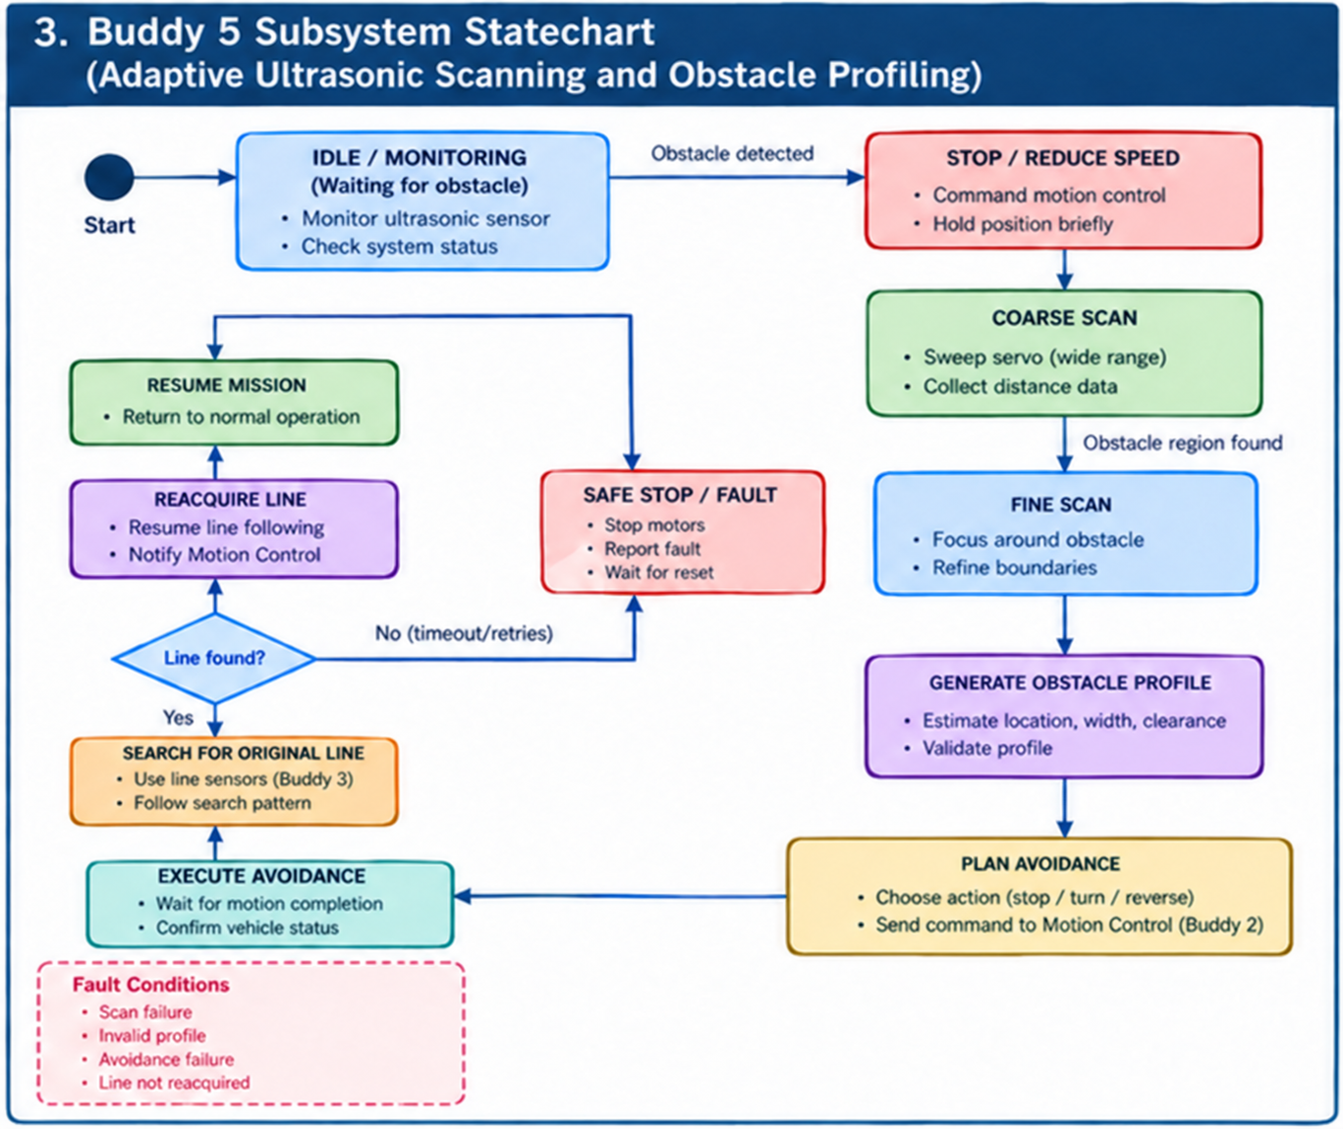
Brief explanation of states, events, and fault handling:
States: The subsystem normally remains in Idle/Monitoring while the robot follows the track. When an obstacle is detected, it requests Motion Control to stop or reduce vehicle speed. The subsystem then performs a Coarse Scan to locate the obstacle region, followed by a Fine Scan to refine its boundaries. The collected distance measurements are processed in Generate Obstacle Profile to estimate obstacle location, width and available clearance. Plan Avoidance selects an appropriate high-level action such as stop, turn or reverse. Execute Avoidance sends the selected command to the Motion Control Task and waits for completion. The subsystem then enters Search for Original Line and uses line information from Buddy 3 to determine whether the track has been reacquired. Once the line is found, Reacquire Line/Resume Mission returns control to normal navigation.
Events: Important transitions include obstacle detected, vehicle stopped/reduced speed, coarse scan completed, obstacle region found, fine scan completed, profile valid, avoidance plan selected, motion completed, line found and recovery timeout.
Fault handling: A scan failure, invalid obstacle profile, failed avoidance maneuver or failure to reacquire the original line within the allowed recovery period causes the subsystem to enter Safe Stop/Fault. In this state, the robot requests motor stop, reports the fault and does not resume normal navigation until the fault is cleared according to the team's recovery policy.

7. Assumptions
List assumptions that the design depends on. Each assumption must state the risk if it is wrong and how the team will validate it before full integration. Have at least 1 assumption per buddy.
ID | Assumption | Risk if wrong | Validation method | Owner | Status
A1 | The Pico W can periodically publish MQTT telemetry and heartbeat messages, and recover from Wi-Fi or MQTT broker disconnection, without blocking or delaying the robot’s time-critical motion, navigation, and safety tasks. | Blocking network operations or repeated reconnection attempts may cause missed RTOS deadlines, telemetry queue overflow, stale or lost telemetry, and delayed robot control or safety responses. | Use the Pico W and Raspberry Pi/Mosquitto to publish representative JSON telemetry at the planned rate while simulated or actual control tasks are running. Disconnect and reconnect the Wi-Fi access point and MQTT broker, and measure task timing, queue usage, message loss, and reconnection time. Confirm that local robot control remains responsive throughout the network failure. | Buddy 1 | Open
A2 | Wheel encoders give reliable, sufficiently fine resolution quadrature signals across the robot's full speed range, including the low creep speed used before turns. | Noisy/inaccurate speed and distance estimates will result in poor straight-line tracking, inaccurate turns, false fault triggers at low speed. | Log raw ticks at min (creep), mid, and max design speed; compare computed distance vs. physically measured distance over several runs. | Buddy 2 | Open
A3 | The robot can reliably decelerate to the fixed creep speed within a short, predictable distance before a queued turn begins, without overshooting into the turn at too high a speed. | Turning while still carrying excess speed invalidates the turn-angle-to-encoder-tick calibration, causing overshoot or undershoot on turns and reduced navigation accuracy. | Bench-test deceleration profile at several starting speeds; confirm the robot reaches creep speed within a consistent distance before triggering the turn transition. | Buddy 2 | Open
A4 | The 3 IR sensors can tell the difference between a barcode and a normal line curve after calibration. | The robot might think a curve is a barcode or miss a real barcode, causing it to make the wrong turn. | Test the robot with different curves and barcodes at different speeds to check if it detects them correctly. | Buddy 3 | Open
A5 | The IMU can provide stable and accurate enough acceleration and gyroscope readings for detecting humps, tilt, collisions and turn rate. | Noisy or inaccurate IMU readings may cause false hump/collision detections or incorrect measurements. | Test the IMU while stationary, during normal movement, over a known hump, and during controlled turns to compare the readings with expected behavior. | Buddy 4 | Open
A6 | The ultrasonic sensor provides sufficiently stable distance measurements over the required obstacle-detection range, and the servo can position the sensor repeatably during coarse and fine scans. | Incorrect distance measurements or inaccurate servo positioning may produce an incorrect obstacle profile, causing an unsafe or ineffective avoidance maneuver. | Repeatedly scan obstacles with known positions and widths at several distances and servo angles. Compare measured distance and estimated obstacle boundaries against physical measurements. Repeat the test at representative robot speeds. | Buddy 5 | Open

8. AI-Supported Design Evidence
Document how AI was used to support the design. The aim is not to show that AI produced perfect answers, but to show that the team used AI critically, corrected weak suggestions, and made final engineering decisions.

8.1 Pre-Submission AI Ideation
Buddy | AI prompt or discussion used | Useful AI ideas | Weak or unrealistic AI ideas | Team decision
1 | Asked AI on the overview of what technology is required and how the setup process should be like | AI suggested technology like MQTT, Grafana, PostgreSQL, Raspberry Pi usage for MQTT setup and telemetry setup | AI suggested technology but did not explain deep enough on how everything was setup in the low-level for deeper understanding | Continue using Mosquitto and Node-RED on the Raspberry Pi, with PostgreSQL as the initial database and Grafana for visualization. Retain separate Telemetry Collection and WiFi/MQTT Communication tasks. Local motion and safety remain on the Pico W, while any remote commands are validated high-level requests rather than direct motor-control instructions.
2 | Asked AI how to approach the Motion Control subsystem (motor driver, encoders, PID) and RTOS task ownership for it. | AI suggested a clear build order, that motor + encoder logic belongs in one RTOS task since PID needs both in the same tight loop, and flagged that command hand-off between moving straight and turning needed explicit queue-check logic rather than treating each move as fully independent. | AI's initial creep-speed number (10-15% of cruise speed) and debounce window (300ms) were rough estimates with no bench-test backing and were accepted only as reasonable starting points to refine later, not as validated values. | The team decided to adopt the single-task structure and the queue-check logic for smooth transitions; kept the creep-speed and debounce numbers as placeholders pending real testing.
3 | Asked AI to help create a statechart for barcode decoding and IR line following, including the states, events and fault handling. | AI suggested having states like Line Following, Barcode Detected, Decode Barcode, and Execute Command. It also suggested having a separate error state for problems like losing the line or detecting an invalid barcode. | Some parts of the first AI-generated statechart were not connected properly and needed to be fixed. | The team decided to kept the main states for line following, barcode detection, barcode decoding, and command execution, and fixed the incorrect connections in the statechart.
4 | Asked AI how to structure the IMU subsystem, identify suitable RTOS tasks, set preliminary priorities, and define subsystem states and fault handling. | Suggested a clear two-task structure and simple state transitions for the IMU subsystem. | Some suggestions were too detailed for the design stage and introduced more states and processing steps. | The team simplified the design and kept only the necessary RTOS tasks and subsystem states.
5 | Review the autonomous robotic car's ultrasonic obstacle scanning and avoidance architecture. Suggest RTOS task separation, scan/profile/avoidance data flow, statechart states, fault cases, and interfaces with motion control and line following. | AI highlighted to separate scanning, profiling and avoidance responsibilities.  Use explicit fault/recovery states  Do not let the obstacle subsystem directly control motor PWM if motion control owns the motors | AI suggested sensors that are not provided.  It assumed exact obstacle geometry can be measured perfectly  Adding unnecessary communication/mobile-app functionality. | Team retained the separation between Obstacle Scan, Obstacle Profile and Avoidance & Recovery tasks because it provides clear ownership and testable interfaces  Motor PWM remains exclusively controlled by the Motion Control Task, while Buddy 5 generates only high-level avoidance commands.

8.2 Team-Reviewed Architecture Freeze
AI or initial idea | Team decision | Engineering reason | Affected artefact
Use Wi-Fi and MQTT to transmit telemetry and receive remote commands. | Accepted with modification | MQTT is suitable for telemetry and supervisory communication, but the robot's real-time movement and safety functions must continue working even if Wi-Fi or MQTT fails. | Communication Task, Task Interaction Diagram, Communication Statechart, NFR9
Use the ultrasonic sensor with a servo to scan obstacles from different angles. | Accepted | Scanning from multiple angles provides more information about obstacle location, width and available clearance than using a single distance measurement. | Obstacle Scan Task, Hardware Pin Layout, Obstacle Statechart
Pause normal line following while a barcode is decoded. | Accepted | This prevents normal steering decisions from conflicting with barcode-based navigation commands. | Buddy 3 Statechart
Use the three IR sensors for both line following and barcode detection. | Accepted with validation required | The existing sensors can support both functions, but physical testing is required to ensure barcode patterns can be distinguished from normal line curves and track conditions. | Buddy 3 Statechart, FR1, FR2, Assumption A4
Return to Idle (full stop) between every move/turn command. | Rejected | A full stop at every manoeuvre adds unnecessary dead time and hurts Completion Time (a graded criterion); decelerating to a fixed creep speed keeps turn-angle calibration accurate without paying the cost of a full stop each time. | NFR12, Motion Control statechart (6.2), Assumptions A2 and A3, RTOS Task Table Purpose field.
Recover from Fault automatically as soon as the condition reads clear. | Accepted | The robot's real-time motion and safety behaviour is fully autonomous, and any remote commands over MQTT are optional, high-level supervisory requests only, so the robot must be able to recover from a motion fault locally without waiting for a remote operator. However, an instant reset risks resuming motion on a brief, flickering fault (e.g. a momentary noisy encoder reading), so a short debounce was added as a safeguard. | Motion Control statechart (6.2), Assumption A2.
Team's initial idea: run the Motion Control task at a 100ms period. | Rejected | A slower period lets wheel-speed corrections lag behind steering decisions, causing drift even when Line Following is working correctly; matching the periods keeps the two tasks tightly synchronized. | RTOS Task Table (Section 3).
Use the IMU to detect humps, tilt, turning and collision-related events. | Accepted with validation required | The IMU provides acceleration and gyroscope data needed for these functions, but filtering and calibration are required to reduce false detections caused by vibration and sensor noise. | IMU Task, Hump & Terrain Statechart, NFR13, NFR14

8.3 Final AI-Vetted Gap Check
After completing the design, ask AI to act as a strict embedded systems reviewer. The review should identify missing requirements, unclear interfaces, untested assumptions, weak mitigations, timing concerns, task conflicts, or resource contention.
Use one of these Team Response options: Fixed, Partially fixed, Accepted as risk, Deferred, Rejected with reason, or Needs validation. The action and evidence columns must justify the selected response.  AI reviewer prompt used | Act as a strict embedded systems reviewer for an autonomous robotic car running on the Raspberry Pi Pico/Robo Pico using micro T-Kernel RTOS. Review the functional and non-functional requirements, hardware pin layout, RTOS task table, task interaction diagram, system-level statechart, subsystem statecharts, assumptions and AI-supported design evidence. Pay particular attention to line following, barcode navigation, motor control, IMU terrain monitoring, ultrasonic obstacle scanning/profiling, obstacle avoidance, line reacquisition and WiFi/MQTT telemetry. Identify only design gaps such as missing or untestable requirements, unclear task ownership, ambiguous queues/events, timing risks, task conflicts, sensor uncertainty, incomplete fault handling and unvalidated assumptions. Do not redesign the system, but list gaps that the team must review and justify.

AI-identified gap | Team response | Action taken | Evidence or reason
Turning directly after a straight segment at full speed would make turn accuracy unpredictable, since the turn-angle calibration assumed a standstill start. | Fixed | Added a creep-speed deceleration step before any queued turn, so turns always begin from a known, calibrated speed instead of an arbitrary carried-over speed. | Reflected in NFR12, the Motion Control statechart (Section 6.2), and Assumptions A2 and A3.
The initial IMU design did not clearly define what happens when IMU calibration fails or invalid sensor data is received. | Fixed | Added fault handling so invalid IMU data is not used for motion or terrain detection, and calibration failure causes the subsystem to enter the Fault state. | Reflected in FR15 and the Buddy 4 subsystem statechart (Section 6.4).
Network or MQTT failure could potentially affect the robot's movement if communication is treated as a dependency. | Fixed |  | NFR9, Communication Task
  Real-time motion, navigation and safety functions remain local to the robot. Wi-Fi/MQTT is mainly used for telemetry and supervisory communication.
Three IR sensors may confuse barcode patterns with normal line curves or track imperfections. | Needs validation |  | Assumption A4, Buddy 3 Statechart
  Added this as an assumption and planned physical tests using different track curves, barcode patterns and speeds.
Barcode decoding could fail or produce an invalid navigation command. | Fixed | Invalid barcode input is handled as an error and the system can return to line following or recovery instead of executing an unknown command. | FR2, FR3, Buddy 3 Statechart
Noisy IMU readings could cause false hump, tilt or collision detections. | Needs validation | IMU data is filtered or validated, with calibration and physical testing required under stationary, normal-motion and hump conditions. | NFR13, NFR14, IMU Statechart
A single ultrasonic measurement may not provide enough information for safe obstacle avoidance. | Fixed |  | Obstacle Scan Task, Obstacle Profile Task
  The ultrasonic sensor is mounted on a servo and performs coarse/fine scanning to produce an obstacle profile containing location, width and clearance.
The Motion Command Queue receives commands from multiple tasks (Line Following/Barcode Decoding for navigation, and Avoidance & Recovery for obstacle handling), but no rule is defined for what happens if two tasks attempt to send commands close together, or which command takes precedence. | Partially Fixed | A fixed command priority order is defined (Safe Stop/Fault > Obstacle Avoidance > Barcode Navigation > Normal Line Following), shown in the Task Interaction Diagram's priority panel, resolving contention between multiple senders to the Motion Command Queue. | Task Interaction Diagram (Section 4).

9. Design Consistency
Use this section to demonstrate that the design artefacts describe one coherent system rather than independent diagrams.
Check | Student Response
Which task owns each hardware device? | The Motion Control Task owns the left and right DC motors and consumes encoder feedback, which is counted by the Encoder ISR / tick counter. The Line Following Task owns the three IR sensor inputs and passes barcode pattern samples to the Barcode Decoding Task, which does not access the sensors directly. The IMU Monitoring Task owns the IMU, while the Obstacle Scan Task owns the ultrasonic sensor and scanning servo. The WiFi and MQTT Communication Task owns the Pico W WiFi interface.
Which task has the highest priority, and why? | No single task is ranked above the others. Motion Control, Line Following, IMU Monitoring, Obstacle Scan, and Avoidance & Recovery share the High priority because they are involved in time-sensitive movement, sensing, obstacle handling or safety-related behaviour; IMU Monitoring runs at a tighter 10 ms period. WiFi and MQTT Communication, Barcode Decoding, Hump & Terrain Analysis and Obstacle Profile are Medium priority because they can tolerate some delay without risking loss of control. Telemetry Collection is Low priority because it does not directly control the robot. The exact priority values are preliminary and will be validated during testing.
Which subsystem statechart corresponds to which RTOS task or subsystem? | The WiFi Communication statechart corresponds to the WiFi and MQTT Communication Task. The Motion Control statechart corresponds to the Motion Control Task. The Barcode Decoding and IR Line Following statechart corresponds to Buddy 3's Line Following Task and Barcode Decoding Task. The IMU-Based Motion and Terrain Monitoring statechart corresponds to the IMU Monitoring Task and Hump & Terrain Analysis Task. The Adaptive Ultrasonic Scanning and Obstacle Profiling statechart corresponds to the Obstacle Scan, Obstacle Profile, and Avoidance & Recovery Tasks.
How are functional requirements reflected in the task and statechart design? | FR1 and FR2 are handled by Buddy 3's Line Following and Barcode Decoding Tasks. FR3 and FR4 are handled by the Motion Control Task using navigation commands and encoder feedback. FR5 and FR6 are handled by the IMU Monitoring and Hump & Terrain Analysis Tasks. FR8–FR12 are handled by the Obstacle Scan, Obstacle Profile, and Avoidance & Recovery Tasks. FR7 and FR13–FR14 are handled by the telemetry and Wi-Fi/MQTT communication system. FR15–FR19 are mainly supported by sensor validation, IMU calibration, motion monitoring and fault-handling logic.
What changes are still expected after the Week 6 review? | After Week 6, the team expects to refine task periods and priorities using actual timing measurements, validate assumptions A1–A6, test barcode detection under different track conditions, verify encoder and IMU performance, and adjust statechart transitions if implementation testing identifies problems. The task interaction diagram may also be updated if testing shows that queue sizes, events or resource ownership need to change.

